The Parish Post
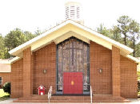

St. Paul Lutheran Church
3253 Niagara Carthage Road
Whispering Pines, NC 28327

December 2019

+ + + + + + + + + + + + + + + + + + + + + + + + + + + + + + + + + + + + + + + + + + + + + + + + + + + + + + + + + +

December 01-Harvest Home St James 3PM
December 04-Advent Service St James 7PM
December 05-Bible Study 3 PM
December 09-Deck the Sanctuary/ Hors
D’oeurve Potluck 6PM
December 11-Advent Service St James 7PM
December 12-Bible Study 3 PM
Church Council 4:30 PM
Girl Scouts Troop 757 6PM
December 15-“Basement Ladies Christmas”
December 18-Advent Service St James 7PM
December 19-Caring Ministry 10AM
Bible Study 3 PM
December 24-Christmas Eve Service 7PM
December 30-Parish Post Deadline 5PM

Four Reasons It Is Good Your Children Are Being Too Loud in Church

By Anna Mussmann

It’s the same for us all. For the Roman Catholics. For the Fundamentalists and Evangelicals. For the Methodists. For the Lutherans. In all of our churches, the babies get loud. The toddlers get grumpy. The children create an ecumenical challenge by stressing-out their parents and failing to behave with the charmingly pious decorum we would all love to see.

Fortunately, the culture in most Lutheran congregations embraces the idea that families should pray and worship together. Most Lutherans recognize that children, too, are Christians who are part of the body of Christ and need to hear God’s word right along with everyone else. We are blessed with a liturgy that feeds not only multiple generations but also connects Christians across time.

Yet, right and proper as it is to see little ones kneel beside siblings, parents, and grandparents, this doesn’t automatically make it easy for parents to teach their kiddos how to behave respectfully in church. Over the years I have seen stressed and frazzled parents trying all kinds of methods to wrangle their offspring. I know how they feel--my own sweet babies have been known to occasionally put their little sin natures on display in the church pew. It doesn’t feel easy to receive the word of God when your kiddos make it impossible to listen for more than a few seconds at a time.

You know what? It’s actually a good thing that your kids are being too loud in church. Here are four reasons why.

One: You are Here
No matter how loud and disruptive your kiddos are (and no matter the reasons--whether they are just being kids, possess challenging personalities, have special needs, or really are mismanaged and undisciplined), it is good you are here.

You are in a place where you can be fed. God’s word and sacraments are powerful, and our Lord is able to work through them despite your children’s behavior and your own distraction. This is good both for you and for your kids.

Of course, your children should to be learning to be respectful. Of course, you should be teaching them reverence and participation. That cannot happen if you make church a quieter place by staying home. Church is a place for flawed, broken, sinful human beings; a place where we learn about the God who made a habit of receiving all kinds of socially inappropriate sinners. Your toddler belongs here, too.

Two: You are Communicating a Good Reminder
You are providing a witness to the people around you--that couple two pews over, the college student in front, your own kids--that going to church is so important that it is worth doing even when it’s hard. When you sway back and forth with that teething baby, when you discipline your toddler multiple times in the narthex, when the sweat runs down your face and you want to give up--you are serving not only your children by taking up the cross of active parenthood, but also the other people around you. Thank you for that.

Three: This is an Opportunity to Teach and Train
Our modern world loves self-expression. We encourage our children to follow their hearts and we love to indulge their whims. Sometimes this is healthy. On the other hand, it is also true that human beings need to learn self-control and consideration for others. Human beings need to be able to repress their heartfelt desires even when doing so is hard. Self-control is learned through practice. If we want our adult children to be able to, say, care patiently for their own children even when they would prefer to scream, shouldn’t we be asking them to practice things like remaining quiet during the words of institution even though they would prefer to make dinosaur noises?

One of the painful (yet good) realities of church is that it makes it hard for us to ignore our own parenting weaknesses. Do we struggle to get our children to obey age-appropriate, simple commands? Do our kids feel entitled to demand snacks or to pull our hair at whim? We might make excuses or “manage around” these issues at home, but the embarrassment of seeing these challenges play out in church can help us recognize areas we need to work on. This is actually a gift, both to us and to our children.

Of course, the mere fact that your kiddo had to be taken out of church--again--does not in itself indicate anything wrong with your parenting. Nor do I mean that we should base decisions on the desire to look like an awesome family in front of others. Nor, of course, should we spend our time in the pew judging other people’s parenting. No child will behave perfectly in church. Not all children develop maturity and self-control at the same rate. The point is that church can bless us with an opportunity to help our own families grow and learn. It’s a pretty nice fringe benefit.

Four: You are Faced with a Vivid Reminder of Sin and Grace
Some of the challenges that children bring are natural and good. Babies are supposed to cry when they are hungry. Toddlers are supposed to want to explore their environment. However, if you are a parent, you have probably also seen your children display humanity’s darker side.

You know. The sweet little boy who glares at you and deliberately kicks the pew in front of him after you’ve told him to stop. The adorable girl who pinches her sister and tries to sneak a cookie out of the diaper bag. The baby who bites you because you took the hymnal away. On any given Sunday in a congregation with children, sin is on display (the adults are just as bad, of course; but they are far more subtle). This is discouraging to parents.

Yet it reminds us--so sharply! --so vividly! --of grace. No matter what stunt your children pull, you love them wholeheartedly. If you had to you would die for them. Parental love is a breathtaking and enormous thing, and it is mind-boggling to ponder the truth that the love of God is inconceivably bigger. Our children help us realize this.

Furthermore, as we see our little ones fail to fully appreciate God’s good gifts, we are reminded that we ourselves are no better. We, too, tune out the words we ought to hear. We, too, focus on our own lives instead of Christ’s body and blood. We, too, are poor, miserable sinners. Seeing our children illustrate our own hearts is a humbling thing. It reminds us how badly we all need to be here. In Church. Where God comes to us.

That is why it is good you and your children are here.

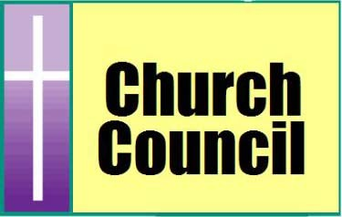

Advent is the beginning of the Church Year. We are fortunate in this country to be able to celebrate the waiting and coming of our Lord and Savior, Jesus Christ.

At St. Paul, we are able to celebrate in many ways. We start with Advent Services on Wednesday evenings at 7pm with St James. Each year we share the midweek services with them. They do Advent and we do Lenten services. This is a time of reflection and rest during this busy time of the year. We all need that.

Also, on December 9th at 6pm we gather for a festive pot luck with heavy hors ’doeurves and good fellowship. It is the time we decorate our church for Christmas. It takes many hands to do this and we hope many will show up to help us. We encourage children to come and help us decorate the Fellowship Hall. After the decorating is done, we sing carols and admire the beauty.

Christmas Eve we celebrate the birth of Jesus with a service at 7pm.

I found the following and I thought I would share it with you. I am not sure how accurate it is, but it is interesting.

The 12 Days of Christmas

1st Day Partridge in a Pear Tree Jesus Christ

2ndDay 2 Turtle Doves The Old & New

Testaments

3rd Day 3 French Hens Faith, Hope &

Charity (The

Theological Vir-

tues)

4th Day 4 Calling Birds The 4 Gospels

and/or the 4

Evangelists

5th Day 5 Golden Rings The first 5 books of

the Old Testament,

the Pentateuch,

which gives the

history of man’s

Fall from grace.

6th Day 6 Geese A-laying The 6 Days of the

Creation

7th Day 7 Swans A-swimming The 7 gifts of the

Holy Spirit – 7

sacraments

8th Day 8 Maids A-milking The 8 Beatitudes

9th Day 9 Ladies Dancing The 9 Fruits of the

Holy Spirit

10th Day 10 Lords A-leaping The 10 Command-

ments

11th Day 11 Pipers Piping The 11 faithful

apostles
12th Day 12 Drummers drumming The 12 points of
doctrine in the
Apostle’s Creed

Every Thursday at 3 PM, Pastor Melms leads a Bible study. During the hour Pastor Melms guides participants through the readings for the coming Sunday. These readings can be found on the monthly calendar attached to the Parish Post. No Bible Study on Dec. 26th.

Elwin Harp (Hip Surgery)
Ida Ciboh (Hospitalized)
Walter Fuhrmann (Heart Problems)
Pam Lyons (Back Surgery)
Jim Aanrud (Back Surgery)
Daryl Pierce (Breast Surgery)
Edward Bonacci (Mobility and Mental Decline)
Phillip Fulghum (Prostrate Cancer)
Megan McClung (Brain Tumor)
Bob Tice (Stroke)
Louise Jensen (Back Surgery)
Lee Neuasier (Breast Cancer)
Mathew Von Seydewitz (Cancer)
Emily Madison (Breast Cancer)
Rob Torns (hip replacement)
David Hennesy (Alzheimer's)
Charles Aquino (Poly-cystic Kidney Disease)
Bob Schultz (Home Dialysis)
Tim Miller (Brain Cancer)
Sandra Shepherd (Bladder Cancer)
Frank Fabish (Cancer)
Jennifer Lewis (Breast Cancer Surgery)
Sondra Nelson (Back surgery)
George Dupy (Kidney Transplant)
Lennard Mills (Cancer)
Mary Schmidt (multiple myeloma cancer)
Kristi Brenneman (Breast Cancer)
Joan Gillis (Ovarian Cancer)
Michelle DeMassi (Breast cancer)
Bob Thompson (Recovering from a Stroke)
Lloydene Meilbrecht

If you know of anyone who should be removed from or added to our prayer list, please email George Venet at gvenet@aol.com. Thank you!

We will be decking the sanctuary out for Christmas on December 9th at 6 pm. This is also our pot luck dinner. Think Hors D’oeurves.

WHAT WE LUTHERANS BELIEVE

It is a good thing to often review the basics of what we as Lutheran Christians believe.

- As we confess in the creeds of the Church, we believe in One God in Three Persons, Father, Son, Holy Spirit.
- We believe that all people are born in sin and must be re-born thru Baptism and the Holy Spirit.
- We believe God the Son became human, born of the virgin Mary, and that the two natures, divine and human, are so inseparably united in one Person that there is one Christ, true God and a true man and that Christ Jesus lived, suffered, died was buried and resurrected to put sin, death and evil to death.
- We believe that forgiveness and salvation are the result of God’s unconditional, unearned and unending love for humanity as coming in Jesus Christ (grace), and that we receive this forgiveness and salvation when we believe this. The ability to believe is given by God the Holy Spirit thru the gift of faith and this faith comes to us thru the preaching of the Story of Jesus (the Gospel).
- We believe that in Holy Baptism thru the washing away of original sin, God grants forgiveness, life, faith and salvation.
- The Gospel teaches that we have a gracious God and that salvation is totally God’s gift and not due to any merit on our part or deeds done by us.
- Good works are expected of those who hear the Gospel and that we should do them for God’s sake and for the help and love of our neighbors as a response to God’s grace in Christ to us.
- The church exists as the assembly of believers among whom the Gospel is preached in its purity and the sacraments are administered according to the gospel.
- We believe that in the Sacrament of Holy Communion (aka Lord’s Supper, Eucharist, etc.) is the true body and blood of Christ and are really present and are distributed and received in the form of bread and wine.
- As we believe so we worship. Lutheran worship should always be a true reflection of what we as Lutheran Christians believe. Orthodox means “right or correct praise.” In our worship we rightly praise the Triune God who has made all of this good news possible and for us and for us to believe it all.

- As we confess in the creeds of the Church, we believe in One God in Three Persons, Father, Son, Holy Spirit.
- We believe that all people are born in sin and must be re-born thru Baptism and the Holy Spirit.
- We believe God the Son became human, born of the virgin Mary, and that the two natures, divine and human, are so inseparably united in one Person that there is one Christ, true God and a true man and that Christ Jesus lived, suffered, died was buried and resurrected to put sin, death and evil to death.
- We believe that forgiveness and salvation are the result of God’s unconditional, unearned and unending love for humanity as coming in Jesus Christ (grace), and that we receive this forgiveness and salvation when we believe this. The ability to believe is given by God the Holy Spirit thru the gift of faith and this faith comes to us thru the preaching of the Story of Jesus (the Gospel).
- We believe that in Holy Baptism thru the washing away of original sin, God grants forgiveness, life, faith and salvation.
- The Gospel teaches that we have a gracious God and that salvation is totally God’s gift and not due to any merit on our part or deeds done by us.
- Good works are expected of those who hear the Gospel and that we should do them for God’s sake and for the help and love of our neighbors as a response to God’s grace in Christ to us.
- The church exists as the assembly of believers among whom the Gospel is preached in its purity and the sacraments are administered according to the gospel.
- We believe that in the Sacrament of Holy Communion (aka Lord’s Supper, Eucharist, etc.) is the true body and blood of Christ and are really present and are distributed and received in the form of bread and wine.
- As we believe so we worship. Lutheran worship should always be a true reflection of what we as Lutheran Christians believe. Orthodox means “right or correct praise.” In our worship we rightly praise the Triune God who has made all of this good news possible and for us and for us to believe it all.
• As we confess in the creeds of the Church, we believe in One God in Three Persons, Father, Son, Holy Spirit.
• We believe that all people are born in sin and must be re-born thru Baptism and the Holy Spirit.
• We believe God the Son became human, born of the virgin Mary, and that the two natures, divine and human, are so inseparably united in one Person that there is one Christ, true God and a true man and that Christ Jesus lived, suffered, died was buried and resurrected to put sin, death and evil to death.
• We believe that forgiveness and salvation are the result of God’s unconditional, unearned and unending love for humanity as coming in Jesus Christ (grace), and that we receive this forgiveness and salvation when we believe this. The ability to believe is given by God the Holy Spirit thru the gift of faith and this faith comes to us thru the preaching of the Story of Jesus (the Gospel).
• We believe that in Holy Baptism thru the washing away of original sin, God grants forgiveness, life, faith and salvation.
• The Gospel teaches that we have a gracious God and that salvation is totally God’s gift and not due to any merit on our part or deeds done by us.
• Good works are expected of those who hear the Gospel and that we should do them for God’s sake and for the help and love of our neighbors as a response to God’s grace in Christ to us.
• The church exists as the assembly of believers among whom the Gospel is preached in its purity and the sacraments are administered according to the gospel.
• We believe that in the Sacrament of Holy Communion (aka Lord’s Supper, Eucharist, etc.) is the true body and blood of Christ and are really present and are distributed and received in the form of bread and wine.
• As we believe so we worship. Lutheran worship should always be a true reflection of what we as Lutheran Christians believe. Orthodox means “right or correct praise.” In our worship we rightly praise the Triune God who has made all of this good news possible and for us and for us to believe it all.

For a full explanation of what we as Lutheran Christians believe, I would direct you to Luther’s Small Catechism, the Augsburg Confession and the Book of Concord.

Submitted by George Venet

ADVENT
THE SEASON OF PREPARATION

Advent is the time in the church year that we begin the preparation. The preparation for what? Why the preparation for Christmas, of course. What do we mean by preparing for Christmas? Why of course it means looking at the calendar to see how many weekends until Christmas. Then we have to decide when we will have our annual Christmas Party for our neighbors and friends. Now we have to send out the invitations and plan the menu for the party. We have to decorate the house for Christmas, which all must be completed before the party. Time must be set aside for baking and cooking the feast for the party. This is a real stressful time.

Well now the party is over. Now we have to turn attention to the family and the Christmas celebration. Thank goodness the house is decorated. But now we must plan what Christmas gifts we will buy for our family and friends. This can be a time of frantic trips to the stores which are usually crowed with other Christmas shoppers. The closer it gets to Christmas Day the more stress we put on ourselves. Every year we promise ourselves we will be better prepared at this time, but every year it is the same thing. We are rushing, rushing and rushing to get ready.

Slow down! Take time! Open up! Remember that Advent is the time of preparation. Advent is the preparation for the coming of our Lord. Where in our hussle and bussle lives have we left time for our preparation for coming of our Lord. Should we ask ourselves what should we be doing? I hope not. We should attend the four Sunday Services before Christmas and the Advent Wednesday Services. Here we will receive the direction where we should set our minds towards Christ’s birth. Messages that we receive through the sermons will remind us of the importance of this season. Slow down! Remember that God is giving us His Son to save us. Take time! Take time to remember the wonderful story of the birth of Christ. We all know the story, but sometime it is good to go over the complete story event after event. Open up! Open up your Bible and read the about the events leading up to and the birth of Christ. (Matthew 1:18-25 and Matthew 2:1-12) and (Luke 2:1-20)

Submitted by George Venet

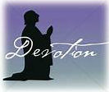
"Welcome!"

Psalm 122:1-2 - I was glad when they said to me, "Let us go to the house of the LORD!" Our feet have been standing within your gates, O Jerusalem!
"Let us go to the house of the LORD." When you hear that invitation, when the opportunity arises to go to God's house for worship, are you glad? We may be happy to hear and respond to the invitation for any number of reasons. Certainly, we come to the Lord's house in glad obedience to His command to remember and keep the Sabbath day holy. We observe Sunday as our day of rest and worship, adding to our joy with the weekly celebration of Jesus' resurrection. We may attend church out of habit, but it is a good habit to have, one we share with our Lord, who went to the synagogue each Sabbath "as was His custom" (Luke 4:16). Perhaps we enjoy the fellowship of worship with our brothers and sisters in Christ, and we usually don't mind a little extra fellowship afterwards—with coffee and donuts. In worship and fellowship, we follow in the footsteps of the saints. Throughout the pages of Scripture, we read of the faithful who gathered to worship, and from the earliest days of the church, the followers of Christ gathered to devote themselves "to the apostles' teaching and the fellowship, to the breaking of bread and the prayers" (Acts 2:42b).
All of the above are good reasons to be glad in the house of the Lord, but there is a greater reason and a greater gladness. When we gather for worship, our Host is there to meet us. After all, it is His house and, like every good host, God welcomes us into His presence. In the house of the Lord we hear the good news that our sins are forgiven for the sake of Christ Jesus. Can there be a greater reason for joy and gladness? Through holy Baptism, God welcomes new children—of all ages—into the household of faith. He sustains and nourishes us in faith as we listen to His Word. The Lord Jesus welcomes us as guests at His table, where He Himself is present in His body and blood. We bring our prayers and offerings to the Lord. Filled with gratitude for His gracious gifts, we join in songs of joyful praise.
Redeemed in Christ, we are, according to Scripture, not only in the house of the Lord, we are a house of the Lord. "Like living stones," we are "being built up as a spiritual house, to be a holy priesthood, to offer spiritual sacrifices acceptable to God through Jesus Christ" (1 Peter 2:5). We offer up to our God and Savior the sacrifices of a repentant heart, of prayer and praise, and our bodies as living sacrifices dedicated to His service all through the week—until we are glad to meet again for worship in the house of the Lord.
THE PRAYER: Our God and Savior, we are glad to be in Your house as we join our brothers and sisters to receive Your gifts and to offer up to You our sacrifice of praise. Amen.
This Daily Devotion was written by Dr. Carol Geisler.
Reflection Questions:
1. Do church-related activities take up a fair amount of your time? Is your involvement where you want it to be?
2. How happy are you when you head off to church?
3. Do you get something special from attending church that beats not going? What is it?

Used by permission; all rights reserved by the Int'l LLL (LHM).

The Lutheran Church—Missouri Synod

LCMS Stewardship Ministry

Jesus, in His Sermon on the Mount, is teaching those who follow Him that worrying about the necessities of life is idolatry: worshipping a false god. This is because worry and anxiety show what we care about. Our anxiety reveals what we love and to what we’re devoted. It reveals what we trust in.

This is why our Lord begins this section with an overarching principle: “No one can serve two masters, for either he will hate the one and

love the other, or he will be devoted to one and despise the other. You cannot serve both God and money.”

But you say: “I must eat and drink. I must have clothing to wear and have a home in which to dwell.” Yes, all these things you need. And Jesus says that your Father in heaven will ensure that you have them. He demonstrates this with a simple argument.

Your Father in heaven feeds the birds of the air, who neither sow, nor reap, nor gather into barns. He clothes the lilies of the field, who neither toil nor spin but are arrayed more luxuriously than Solomon in all his glory. If, then, your Father in heaven feeds the birds and clothes the lilies, how will He not also feed and clothe you when you are worth more than they are?

For you know that you are worth more than them. You are worth infinitely more. You are worth the price of the eternal Son of God. Did the Son of God come down from heaven and become a lily? Did he descend and take on the form of a bird? No!

He came down from heaven and became a man: flesh of our flesh and bone of our bone. He is one of us, our brother. And what did He do when He became flesh to dwell among us? He gave His holy, precious blood and His innocent suffering and death, that you might be His own and live under Him in His kingdom forever.

God became man in Christ Jesus. He lived the life we failed to live, and He died the death we deserve because of it. He was raised again on the third day to overcome sin and death … for us. He was crucified for our transgressions and raised for our justification. So, if your Father in heaven has given His Son to die for us in order that we might live with Him eternally, how will He not also give us all things to support this body and life?

To be anxious about the necessities of life, to devote yourself to food and clothing, to care

about this and find security in it, is to serve another god. It is to deny that you will live forever because Jesus, the Son of God is risen from the dead, lives and reigns for all eternity. It is to believe that God – who created you, redeemed you by the death and resurrection of His Son, and sanctifies you by His Spirit – will not keep His promises of sustaining you in this life.

Jesus says this: Seek first God’s kingdom and His righteousness. God’s kingdom is His rule among us. His rule among us comes when our Father in heaven gives us His Holy Spirit, so that by His grace we believe His holy Word and lead godly lives here in time and there in eternity. This is what we ask God to do for us in the prayer Jesus taught us.

Your Father in heaven knows what you need – food and clothing, house and home, etc. – and He promises to give it to you. Chief of the things you need is His grace and mercy in His Son, Jesus Christ. So, seek after that. Those who seek will find. And all the necessities of life, our Lord says, will be added to you.

The Caring Ministry meets the 3rd Thursday of every month at 10 AM. During this time we assemble Cancer Care Kits and, in the near future, we will again be working on pillow-case dresses for Tiny Hearts Orphanage. We would enjoy having you join us the 3rd Thursday to be a part of this important out-reach to the community and the world and for a time of fellowship.

We also provide transportation to doctor appointments, hospital, shopping, etc. when requested. We can also provide meals if there is a need. If you or someone you know in the St Paul family or in the neighborhood who is in need, please contact Louise Jensen.

If you are willing to help with this by driving, providing a meal or even visiting someone in need again let Louise know. This ministry is here to help our church family and those in our community.

In October we assembled 50 Cancer Care Kits and delivered them to the Oncology Department in Pinehurst. Items included in these kits are:

Tissues (small individual)
Small Prayer or Inspirational Booklets
[like Portal of Prayers (we have been
substituting Inspirational bookmarks)]
Bottles Water (small bottles)
Pencils (sharpened or mechanical)
Puzzle Books
individually wrapped candy
Sandwich Cracker packs
Gift Bags or white lunch bags (which
are marked that they are a gift from
St Paul)

Your donations are greatly appreciated. Donation of any of the above items can be put in the basket in the Narthex. Or if you would rather have a member of Caring Ministry to purchase the items for you, simply add a little extra to your Sunday envelope and mark the last line Caring Ministry and the amount you of your gift.

These kits cost a little over $2 each to assemble, really this isn’t much when you consider the blessing it gives to the recipent. Thank you to all who have donated to this mission with not only items, money but also with the time you give helping to assemble and deliver the kits and with your ongoing prayers..

In addition to the kits, we also deliver cancer caps to the unit. If you are interested and have time to knit or crochet caps, your effort will be welcomed. If you need directions, there are some posted in hallway by the Fellowship Hall.

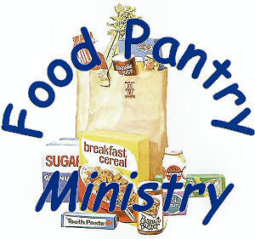

Suggested food items are: 1 pound bags of rice, boxed mac &cheese, Dry Pinto or Lima Beans, canned fruit, vegetables, soup, meat or corne beef hash, peanut butter, jelly, oatmeal, crackers, cookies, graham crackers, ginger snaps.

Suggested Hygiene Products are: soap, toothpaste, toothbrush, shampoo, deodorant, toilet paper, tissues.

They also accept new and gently used: sheets, blankets, towels and washcloths.

"Going Public"

Acts 4:18-20 - So they called them and charged them not to speak or teach at all in the Name of Jesus. But Peter and John answered them, "Whether it is right in the sight of God to listen to you rather than to God, you must judge, for we cannot but speak of what we have seen and heard."
Comedians are people who try to get you to laugh by saying funny things.
Over the years, I've run into many people who think they are comedians when it

comes to their faith. One of the lines these imaginary comedians love to say goes something like this: "I don't have to go to church on Sunday. I know what I believe, and that's enough. After all, faith is a private matter between me and God, isn't it?"
I know they think they're being funny because, almost always, they say those words with a wink and a smile.
At first, when people said such things to me, I replied with a scowling, "Where did you get that idea? That's just about the silliest thing I've ever heard." My response was neither welcomed nor appreciated. More often than not it ended the conversation.
So now when people say their faith is a private matter, I agree with them and say, "You know, I've looked through the Bible, and I've found a number of people who agree with you."
When they say, "Really? Who?" I am free to share:
1. "Well, there was Moses. He didn't want to talk to Pharaoh about freeing God's people."
2. "Then there was Jonah. He didn't want to tell the folks of Nineveh about their sins."
3. "Then there were the disciples who, after Jesus' crucifixion, kept themselves locked away."
4. "There also were the Jewish leaders who told the apostles to keep their faith to themselves."
The reaction is usually something like this: "I didn't know that." All those folks thought their faith was a private thing.
The only problem with their thinking was God didn't agree. It's then I mention to the fellow who wants to keep his faith private,

"Of course, you realize God shot down all of Moses' excuses and sent him to Egypt. And the Lord used a miracle to turn Jonah around to go and preach words of repentance. And the disciples were eventually given the Holy Spirit, and then they couldn't stop talking about Jesus. And when the Jewish leaders told them to be quiet, they said, "We cannot but speak of what we have seen and heard."
The last thing I share is this: "My friend, you are a believer today because for 2,000 years people have shared Jesus' story. Through the ages, people around the world have conveyed their faith with others. I finish with, "But, of course, I could be wrong. Can you tell me where in the Bible you've heard the Lord say, 'Don't go and preach the Gospel' and 'Don't baptize them in the Name of the Father, Son, and Holy Spirit,' and 'Don't teach others all that I have commanded'?"
Naturally, they can't do that.
Blessings on you as you share Jesus' love today.
THE PRAYER: Dear Heavenly Father, bless the Good News I share with others about Your Son who died to redeem us. In Jesus' Name I pray. Amen.
Excerpted from a message by Rev. Ken Klaus, former Speaker of The Lutheran Hour
Reflection Questions:
1. What's the funniest reason you've ever heard for someone not sharing their faith?
2. Do you think people felt more compelled to share their faith in New Testament times than they do today? Why might this be so?
3. What do you do to overcome your hesitancy to share your faith?

Used by permission; all rights reserved by the Int'l LLL (LHM).

December 03 Marianne Regler
December 08 Joni Harris
December 11 Ethan Hunt
December 18 Ace Beck
December 20 Sandra Shepherd
December 28 Joe Loomis
December 31 Carol Schneider

December 20 Richard & Stephanie Beck
December 31 Paul & Alyssa Whaley

If we have missed your birthday or anniversary or have a wrong date, we do apologize. Please send the information to ParishPost1@gmail.com or put a note in Church Office. We will add you to our lists. Thank You.

Serving your Church Family; every Sunday we have some volunteer opportunities for you to participate and your help is needed:

Church Care – Open the church for service, set up for the Fellowship for before and after
the worship service. Clean-up following the fellowship. Check with Elsie and she will give you the low down on this.

Altar and Sanctuary Care – Prepare the Altar for Service, Communion and clean-up after service. See Jean Davis or Carol Schneider for more information.

Greeters/Ushers – Welcome those attending the service, hand out bulletins, have visitors sign the visitor’s log, record the sermon, collect offering, usher Communicants to the table for Communion and collect bulletins left in pews and separate the order of service and put in the Church Office. See Louise Jensen if you have questions or need more information.

Lector – Read the lessons for the day

Communion assistant – assist the Pastor during Communion

Six-year-old Angie and her four-year-old brother Joel were
sitting together in church. Joel giggled, sang, and talked out
loud. Finally, his big sister had had enough. "You're not
supposed to talk out loud in church." "Why? Who's going to
stop me?" Joel asked. Angie pointed to the back of the
church and said, "See those two men standing by the door?
They're hushers."

Facebook – St Paul has their own Facebook Page … St Paul Lutheran Church Sandhills NC. Check it out. We hope to use this as an outreach into the communities in the area. Let us know if you like what you see.

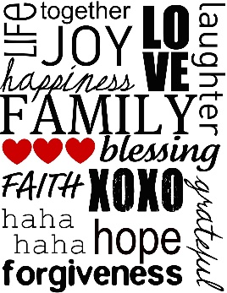
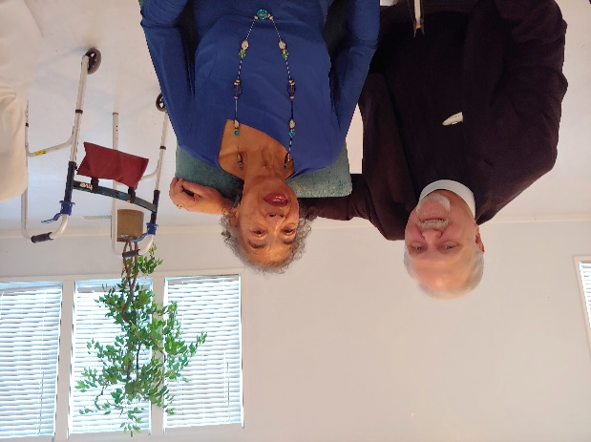
Pastor and Sonra

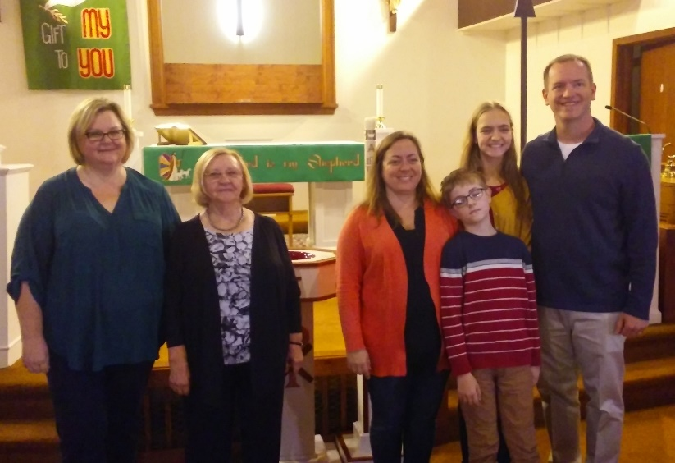
New Members

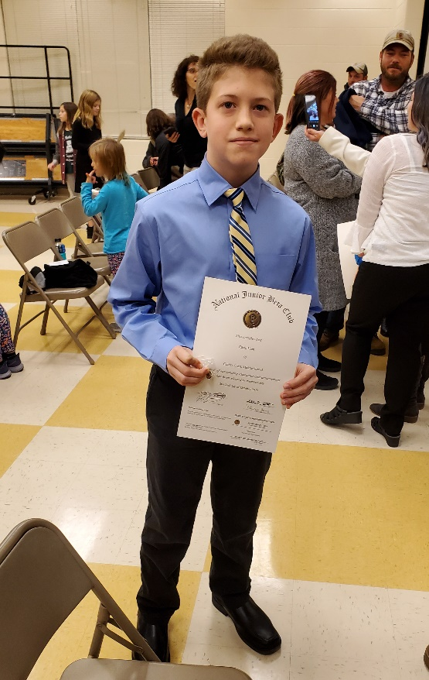
Ethan inducted to the Beta Club

George with his new Grandson

Less of George and More of Grandson

Almond Bark

1 cup almonds (whole raw)
1 bag of Dark/Semi Sweet Chocolate
1 heaping tablespoon of Coconut Oil
1 Teaspoon of Vanilla Extract
Coarse Sea Salt

- Roast almonds 5-10 minutes, let cool, coarsely chop.
- Use double-boiler and add Chocolate, Coconut Oil, and Vanilla.
- Once melted stir in almonds.
- Put parchment paper in a 9 x 13 inch pan. Spread chocolate evenly.
- Sprinkle with Sea Salt.
- Refrigerate.

Once the mixture hardens crack it into bite size pieces. Keep in the refrigerator until use. Store any leftovers in a zip lock bag in the refrigerator.

An added note is that I have used pecans and it seems to work out tasting equally good.

Submitted by Mary Melms

Easy Breakfast Croissant Puff

Ingredients
• 4 large croissants ,cut up into pieces (about 6 full cups)
• 1/2 cup fresh or frozen blueberries
• 1/2 cup fresh or frozen raspberries
• 8 ounces cream cheese ,softened
• 2/3 cup granulated sugar
• 2 large eggs
• 1 teaspoon vanilla
• 3/4 cup whole milk

Directions
1 Preheat oven to 350 degrees F. Lightly coat a 9-inch square pan with cooking spray.
2 Place croissant pieces in the pan. Scatter the blueberries and raspberries over the top.
3 In a medium bowl with an electric mixer, beat cream cheese and sugar until combined and smooth. Add in the eggs and vanilla and beat until well blended. Gradually add milk, beating well after each addition.
4 Pour mixture evenly over croissant pieces. Gently pat down with a wooden spoon so all the pieces are coated. Let rest 10-15 minutes.
5 Bake for 35 to 40 minutes or until set in center and golden brown. (If top starts to get too brown toward the end, cover with foil.)
6 Serve warm with powdered sugar sprinkled on top.
Recipe Notes
• Croissants are made in all different sizes. What I consider large, might not be the same thing to you. Just make sure they render about 6 full cups once cut up.
• Croissants are light and soft, so the liquid is absorbed pretty fast. If you use a different type of bread, adjust the resting time accordingly.
• This recipe can easily be doubled in a 9X13 pan. Also feel free to customize the type of fruit used to suit your taste.

Submitted by Pam Venet

PIE CRUST

2 c. flour
1/2 tsp. salt
1/2 c. vegetable oil
6 tbsp. cold water

Combine dry ingredients. Add the cold water to the oil. Pour into the dry ingredients and mix. Roll between wax paper to desired thickness.

Classic Southern Pecan Pie

Pastry for a one crust pie
4 - eggs
1 (1-lb.) pkg. - Domino® Light Brown Sugar (approx. 2 1/3 cups)
3/4 cup - water
1 cup (4 oz.) - pecan halves
1/4 cup - butter or margarine, softened
1 teaspoon - vanilla

Preheat oven to 350°F. Line 9-inch pie pan with pastry; trim and flute edges.

Beat eggs in a small bowl until frothy; set aside. Combine sugar and water in 2-quart heavy saucepan. Place over medium heat, stirring until sugar dissolves. Bring to a full rolling boil and cook for 3 minutes. Gradually stir hot syrup into eggs. Add pecans, butter and vanilla to mixture. Pour filling into pastry-lined pie pan.

Bake at 350°F for 45 to 50 minutes or until set. Cool.

Sand Tarts

1/2 cup butter
1 cup sugar
2 egg yolks - save egg whites
1 Tbl. Sour milk
1/2 tsp. vanilla
1/2 tsp. salt
1 tsp. baking powder
1 1/2 cups flour

Combine and beat together - butter, sugar and egg yolks. Add milk & vanilla & blend well. Combine flour, baking powder & salt. Add to butter mixture. Mix in thoroughly to form cookie dough. Wrap in wax paper & refrigerate overnight. Cut off a portion of the dough and roll on a floured pastry cloth. Roll very thin - 1/8" or less and cut with a round cookie cutter(2 to 3" diameter). Place on cookie sheet.

Beat egg whites lightly. Using a fingertip, gently dab egg white on centers of unbaked cookies. Sprinkle lightly with a cinnamon-sugar mixture over the egg white area. Place a nut in the center of each cookie & press lightly to hold in place. May also use colored sugar to decorate.

Bake in a preheated 350º oven for about 6 to 8 minutes. Check cookies in oven starting at 6 minutes, since these thin cookies can quickly become too dark. Remove from cookie sheets as soon as baking is finished. Cool completely before stacking and storing. Best if stored for a
week or two before eating.

Super Easy Donuts

This is one of the easiest recipes you will find. 1 ingredient and oil to deep fry it in.

1 can dinner rolls

Cut the dinner rolls in half and deep fry (400º) until golden brown, turn and fry other side.
Top with powdered sugar or cinnamon sugar.

Weekly and Monthly Parish Post Preparation

If you have any announcements to be included in the weekly Parish Post please submit them to ParishPost1@gmail.comby 5 PM the Wednesday before service (except for the last week of this month, by Tuesday the 24th).

December Monthly Parish Post articles need to be sent to ParishPost1@gmail.com by 5 pm Monday, December 23rd.. Please feel free to send in articles of interest, Recipes and/or pictures of our Church family (which includes your family … have a new grandchild, share their picture and let us ooh and ahh with you).
The Dates have been moved up a day due to Christmas Holiay.

Thank you.

CONTACTS

Pastor John Melms
(307) 214-8166
Email: jmelms@yahoo.com

Church Email
StPaulLutheranChurchSandhills@gmail.com

Church Website
www.stpaulinthepines.com

Church Facebook Page
St Paul Lutheran Church Sandhills NC

Church Phone
910-949-2345

Church Council
Louise Jensen
919-499-4968

Outreach & Evangelism
George Venet
910-949-2470

Property
Elsie Jasinski
910-295-2766

Education
Michele Dusch
910-673-3369

Weekly and Monthly Parish Post
Claireann Haines/Carol Schneider
910-582-5807 / 919-498-2269
Email: ParishPost1@gmail.com

Join MTQ and the Whisnants at the Fair Barn for the Home For Christmas Tour! More info: 252-290-0560 or ChristmasOutreach19@gmail.com
This will be a night to raise money for the BackPack Pals Program which is a division of the Food Bank of CENC that provides weekend snack packs to children in need.
Join us for a GREAT night of music and fun to support a GREAT cause!

