**The Parish Post**

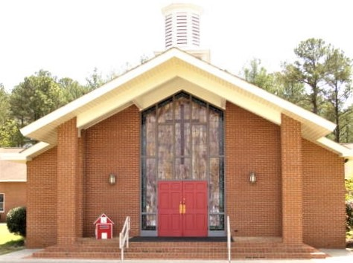

**St. Paul Lutheran Church**

**3253 Niagara Carthage Road**

**Whispering Pines, NC 28327**

**August 2018**

+++++++++++++++++++++++

**Council News:**

The Call Committee has met and is in the process of interviewing 4 Pastors to lead us. We will be interviewing them over the next few weeks and when the process is done, we will get the names and information to the congregation. We will again have a Call Service as we did a few months ago and when I set that with Rev. Daub, you will be notified.

Our Education Chairman has taken a few months off to care for her brother in Florida. We wish Michele Dusch well and await her return. In the meantime, Dena Barto has taken over the leadership for Vacation Bible School which will run from August 6th to the10th. Friday, the 10th, will be a closing party and the families of the 12 children signed up for VBS will be invited to join us for Pizza, Salad and Dessert. As we have children who are not members of our church, this will be an Outreach to the Community. If you can help out in any way, please see either Dena Barto or Louise Jensen.

We are planning to start Sunday School again in September. This year it will be held after church during coffee hour. We need people who will be willing to teach. If we get 4 people, you would only have to do it once a month. Please let Louise Jensen know if you will be willing to help in this outreach for our children.

Summer is usually a time of rest, relaxation, and vacations for many people. Activities slow down and life eases up. One thing that does not stop is Church. If you are going to be away, please remember your commitment to St. Paul. Likewise, if you have fallen behind in what you planned to give this year, now is a good time to catch up.

Your Council wishes you a peaceful and relaxing rest of summer.

**Vacation Bible School:** St Paul's Lutheran Church will be having a VACATION BIBLE SCHOOL this summer. Starts August 6th thru the 9th, from 9 am until 12 noon, Ages 4 to 10.

We are planning to have stories from the BIBLE, Games, Singing. Snacks and  beverage.

We are in need of help, if you can help out contact either:

Dena Barto 928-637-4321

Louise Jensen 919-499-4968

**Youth Sunday School:**

Starts September 9th.

Ages 4 and up.

Volunteers are needed to help teach.

**Alzheimer’s Association Walk**

Most of you know that my wife Anne passed away last December from Alzheimer’s disease.  My daughter Judith and I have been participating in a walk for the past several years to raise funds to fight this disease.  We will be walking again this year on October 6 at the lake park in Aberdeen.  I would appreciate any support that you can give to try and find a cure.  To support our team ‘Annie’s Friends’ on-line, please follow the directions below:

Logon on to www.alz.org

Click on “Find Your Walk”

At the top of the panel click “Teams”

Enter Annie’s Friends in the “Find a Team” box and click on “Search”

Select Annie’s Friends

Select “Donate to the Team” on the right side of the panel

Follow the “Gift Information” panel and enter the data requested

If you would rather send a check, you can give it to me or send it directly to the Alzheimer’s Association but please note the 'team name' and 'Aberdeen Walk' on the check so that we get credit for it.

Thank you so much for your consideration, Henry Fuhrmann, 910-695-0509, henryf@nc.rr.com

#### Dimensions of prayer

Prayer has four interwoven dimensions: speaking, listening, contemplation and community. Understanding these dimensions can help us become more faith-filled prayers and guide us into healthy ways of praying.

Speaking to God is often what comes to mind when we think about prayer. Here the person praying is doing all the talking. Many types of speaking prayers are found in the Bible, including petitions, lamentations or confession.

Listening to and for God is the second dimension of prayer. Igor Stravinsky once said, “To listen is an effort, and just to hear is no merit. A duck hears also.” In our conversations with God, we are to be more than ducks. Listening is hard to do in our chaotic, noisy world—especially when we think we must do all the talking. But without listening, prayer is one-sided. Listening to God takes energy even though it is a receiving experience. In prayer, we strive to actively let go and let God talk. In these listening prayers, God chooses to speak to us through a variety of means including, but not limited to, Scripture, sermons, devotions, music, art, nature, other people’s voices or actions, knowledge, and events or experiences that happen in our lives. When we listen for what God may be saying to us in the moment, rather than listen merely for what we want to hear, we may hear some amazing things.

Contemplation or seeking God’s presence is the third dimension of prayer. No one is speaking, but communication comes through contemplation and awareness of God’s presence. While God is always aware of us, we aren’t always aware of God. This aspect of prayer is like being in the same room with a person or pet you love, without saying a word, yet being aware of their presence and being present with them.

Community is the fourth dimension of prayer. Whether we’re praying silently alone or aloud among others, the community is always present with us. We pray the Lord’s Prayer with fellow believers, but we pray for others as well, which brings the community into our midst even when

(cont.)

we’re alone. Hearing others pray aloud nurtures our own faith in God. In fact, we usually learn to pray by listening to others. When no one prays out loud, how will we learn to do it? And if we always make the pastor our official prayer giver, how can we practice so that when the pastor isn’t present, communication with God doesn’t stop? Prayer is never just about the pastor. It always involves the community of which we are a part.

What does it mean to pray well? I believe it means simply to be in conversation with God, regardless of what is said or how. When we pray out of authentic faith and open ourselves up to the Holy Spirit’s working in us, we can never say a wrong or bad prayer. And regardless of what we say, God has promised to listen and respond, perhaps not in ways we expect or want, but certainly in ways that guide us towards God’s desires for our lives. So let us pray! God really does want to hear from us.

George Venet

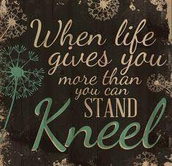

**Our current prayer list is below:**

Dorothy Loughran (Brain Cancer)

Rod Ward (Bladder biopsy)

Sandra Shepherd (Bladder Cancer)

Richard Rindflesich (Prostrate Surgery)

Jennifer Lewis (Breast Cancer Surgery)

John Rossi (Colon Cancer Surgery)

Frank Fabish (Cancer)

Joanne Perry (Chronic Lung Disease)

Jennifer Lewis (Breast Cancer Surgery)

Sondra Nelson (Neck surgery)

Barbara Nelson (Hospitalized for breathing Problems)

Katelyn Krause (Spinal Surgery)

George Dupy (Kidney Transplant)

Jeannie Lloyd (Heart Surgery)

Carol Ward (Breast Cancer)

Lennard Mills (Cancer)

Mary Schmidt (multiple myeloma cancer)

Kristi Brenneman (Breast Cancer)

Jane Adams (acute leukemia)

Peggy Ballew (lung cancer)

Robert DeSandy (Physical Limitations)

Lisa Brown (cancer)

Joan Gillis (Ovarian Cancer)

Michelle DeMassi (Aggressive breast cancer)

Bob Thompson (Recovering from a Stroke)

Lloydene Meilbrecht

**If you know of any of the individuals on our prayer list who have recovered or no longer need our prayers, please email me so I may remove their names**

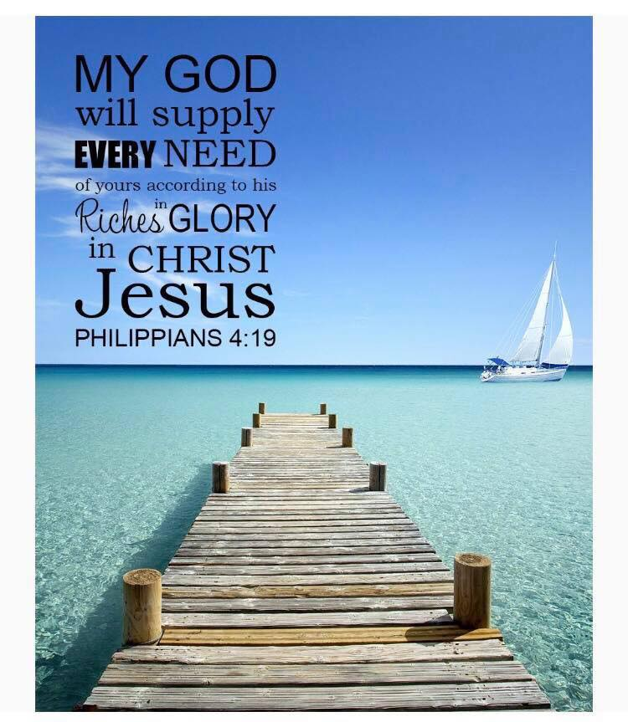



In spite of our foolish and sinful ways, God calls us to be His Workers. Scripture tells us that Jesus did not pick people from society’s elite when he chose his workers. Jesus’ disciples were peasants, fishermen, and even a tax collector. Paul wrote, *“Brothers, think of what you were when you were called. Not many of you were wise by human standards, not many wer influential; not many were of noble birth. But God chose the foolish things of the world to shame the wise; God chose the weak things of the world to shame the strong. He chose the lowly things of this world and the despised things …”* (1 Corinthians 1:26-28). The majority of God’s work was done and continues to be done by the lowly and oppressed people.

Certainly, God can use celebrities and very successful people in His work. However, we need to remember that even though we may not have accomplished anything of worldly significance, broken any records, or won any awards, God can use and transform us into effective workers in His kingdom. *“ I can do everything through Him Who gives me strength”* (Philippians 4:13). Society gives many accolades to those who succeed, but there is no greater honor or privilege than to be chosen as God’s vehicle to spread the Gospel. As John states in his Gospel, it is Jesus Who does the choosing *“You did not choose Me, but I chose you and appointed you to go and bear fruit”* (John 15:16).

So why does God elevate the foolish and the lowly to be His workers? A reason may be found in 1 Corinthians 1:29 *“so that no one may boast before Him”*. It is only by God’s grace that we are saved, called, and equipped to be in His service. If we come into God’s work with impressive credentials, we risk taking the glory and credit for ourselves. God desires the weak and the lowly. As Paul said, *“Therefore, I will boast all the more gladly about my weakness so that Christ’s power may rest on me. That is why for Christ’s said I delight in weaknesses, in insults, in hardships, in persecutions, in difficulties for when I am weak; then I am strong”* (2 Corinthians 12:9-10) God uses ordinary people to do extra-ordinary things. Are you ready for duty?

**ST. PAUL L:\St Paul\Monthly Pasish Post\pics\missions1.jpg**

**FOOD PANTRY DONATIONS**

St. Paul Lutheran Church supports both the Sandhills/Moore Coalition for Human Care and the We Care Food Pantry. Donation baskets are in the narthex.

**CARING MINISTRY**

The Caring Ministry is a group of women who get together once a month to put Cancer Care Kits together for the Oncology Department at First Health. We also sew pillowcase dresses for The Tiny Hearts of Hope Orphanage in Viet Nam. But that is not all we do. We also provide transportation to doctor appointments, hospital, shopping, etc., if needed. We provide meals if there is a need. However, we do not know when to do this so we need you to tell us. If you know of someone in our church or perhaps a neighbor who is in need, please let Claireann Haines or Louise Jensen know. This Ministry is here to help those outside our church but also those within our church. If you would like to be a part of this ministry, we meet on the 4th Thursday of the month at 10am. Please let us know if you are willing to drive, provide a meal, or just visit someone in need.

**Cancer Care Kits:** In July we delivered Cancer Care Kits to First Health Oncology. Thank you to all who furnished the items to put in the kits or the money to purchase the items and our knitters who made cancer caps.

The Caring Ministry is in need of the following items for the Cancer Care Kits:

Tissues (small individual packs)

Small Prayer or Inspirational Booklets

(such as Portals of Prayers)

Bottled Water

Pencils – sharpened (or mechanical

Pencils)

Puzzle Books (Fill it in, Find a word,

Sudoku, etc.)

These items will be put into bags to be given to patients receiving chemo at First Health Oncology.

**PILLOW CASE DRESSES:**

We are in need of:

New or gently used pillowcases

Double fold bias tape

¼ inch elastic

Donations can be left in the Caring Ministry Bin in the Narthex.



**Weekly and Monthly Parish Post Preperation**

If you have any announcements to be included in the weekly Parish Post please submit them to Claireann Hanies at toffeeh@aol.com by 5 PM the Wednesday before service.

September Monthly Parish Post announcements need to be sent to Claireann Haines at toffeeh@aol.comby 5 pm Tuesday, August 28th.

Thank you.

**August Birthdays:**



August 3:

Linda Ciboth

Gary Gee

August 8:

Johann Ciboth

August 18:

Rachel Young

August 22:

Andrea Vice

August 23:

Louise Jensen

Pastor John Melms

If we have missed an anniversary or birthday, I am sorry. Please send me the information (toffee@aol.com) and I will add you to our list. Thank You!!

**CONTACTS**

Pastor John Melms

(307) 214-8166

Email: jmelms@yahoo.com

**Church Website**

http:/stpaullutheranchurchwhisperingpines.org